Article | Children’s rights  Whole School Charter | Children respecting their rights and the rights of others | Adults Respecting children’s rights
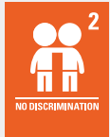 | All children have all these rights, no matter who they are, where they live, what language they speak, what their religion is. | - We will support each other in knowing our rights  - We will show respect for each other by listening and showing kindness | - Adults will treat all children equally and fairly  - Adults will get to know children as individuals  - Adults will work with other professionals to ensure all children can exercise their rights
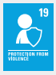 | All children have the right to be protected from being hurt and mistreated, in body or mind. | - We will use kind words to our peers  • We will use kind hands and tell our friends about using kind hands.  • We will help one another to learn about being kind.  • We will keep safe by walking inside in case we fall.  • We will take turns and share the toys in nursery and help other children to learn about sharing. | - Adults will respect children’s rights by protecting them from harm and promoting a healthy happy child.  - Adults will work in a multi-agency response to support children’s physical health and well-being.  - Adults will teach children about their rights by promoting positive behaviour and modelling rights respecting language.  • Adults will give encouragement and praise and teach children about being safe.  - Adults will encourage children to be citizens, supporting their local community and globally helping all children across the world to have their rights upheld.
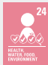 | All children have the right to the best health care possible, safe water to drink, nutritious food, a clean and safe environment, and information to help you stay well. | - We have the right to drink fresh water throughout the day, we show other children where to access clean water.  • We will try new foods and textures and help other children know they have the right to nutritious food  • We will keep ourselves safe by washing our hands before eating and after going to the toilet.  • We will help to keep the environment safe by helping to tidy up and help other children to tidy up. | - Adults will provide a water station for free access to water  • Adults will provide cooking activities that promote healthy eating and physical health  • Adults will model hygiene routines such as washing hands and talk to children about their right to be clean and healthy  • Adults will provide routines that promote children to know their rights about living in a safe clean environment. (Health for Life Award 2019) is embedded in practice
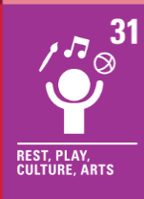 | Every child has the right to rest, relax, play and to take part in cultural and creative activities. | - We will share the toys at Nursery  - We will work together as small groups  - We will ‘have a go’ at different activities | - Adults will support children in learning to share  - Adults will encourage children to work together in small groups such as, Talking Buddies/Book buddies.  - Adults will support learning experiences that celebrate different cultures and religions
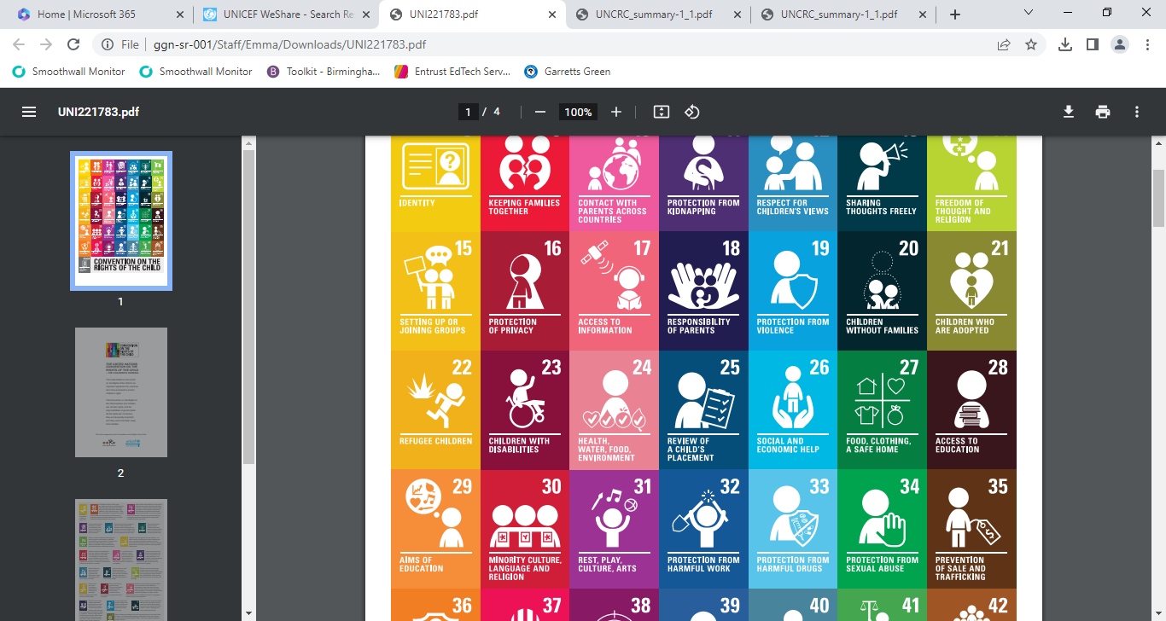  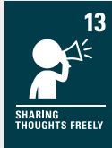 | All children have the right to an education that supports children to use and develop their talents and abilities. It should also help you to live peacefully, protect the environment and respect other people.  Children have the right to share freely with others what they learn, think and feel, by talking, drawing, writing or in any other way unless it harms other people | - We will be good listeners to our teachers and each other  - We will share knowledge with each other and our teachers  - We will help tidy up  - We will grow and water plants  - We have the right to be listened to but also we need to listen to our friends.  • We have the right to share our ideas and throughout need to listen to our friends ideas so they have their rights too.  • We have the right to be respected but need to show respect to others as this is their right.  • We have the right to our own beliefs and celebrate our culture but will share the rights of others by joining in celebrations and learn about other cultures and religions.  - We will be good listeners to our teachers and each other | - Adults will get to know each child as an individual  - Adults will provide learning experiences suitable to each child  - Adults will work with other professionals to ensure all children can access the curriculum  - Adult will respect children’s rights by listening to them.  • Adults will respect children’s rights by ensuring a flexible curriculum that supports children’s individual needs through differentiation in planning and teaching.  - Adults will ensure all children have a voice through different vehicles, for example floor books  • Adults will respect children’s rights by providing opportunities to learn about each other’s religion and cultures  • Adults will respect children’s rights and ‘dignity’ by promoting positive behaviour and respect for everyone.
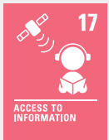 | Children have the right to get information from the Internet, radio, television, newspapers, books and other sources. Adults should make sure the information they are getting is not harmful. Governments should encourage the media to share information from lots of different sources, in languages that all children can understand. | - We will respect and take care of the books in nursery.  • We will ask questions around things we are interested in.  • We will share our ideas  • We will listen to each other and take turns in conversation.  • We will take turns and share the toys in nursery  - We will use our school library to share books at home  - We will visit our local library on a school trip | - Adults will be positive role models to support children to enjoy reading.  • Adults will promote positive behaviour management • Adults will talk about e-safety when accessing on line information.  - Adults will support parents with e-safety at home by signposting and providing guidance on these  • Adults will ensure children have access to information to extend their learning and knowledge on a particular subject matter. (Pic News)  • Adults will help children find out about things they do not understand.

